Scope
We have found a few examples of a wrongly mounted capacitor (C-14) in the power supply in the PM5661 Waveform monitor and vector scope.
The suspected instruments are produced between Spring 2003 and Spring 2004.

If this capacitor is mounted in reverse direction it will eventually cause a failure of the power supply after typically one year.

This note helps you in determining if your waveform monitor has this wrongly inserted capacitor

How to determine if action is needed

The below photos and drawings depict where to look.

- Overview of power supply seen from bottom side

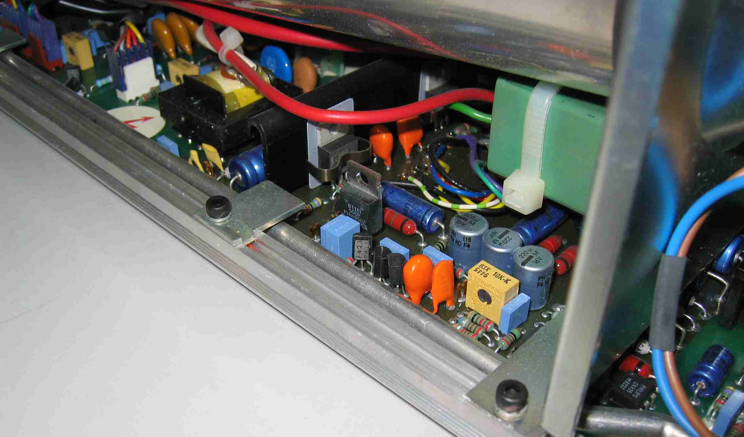
Area to check

2. Detailed view of C-14 correctly mounted
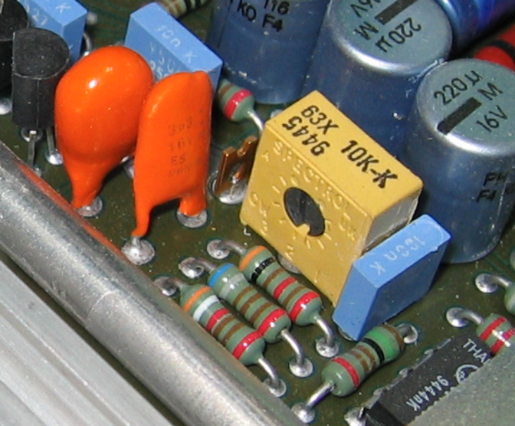
Note that the two orange coloured electrolytic capacitors are mounted back to back.
C14: 3.3µF/16V
Text readable from this side

If text on C14 is NOT readable from this side the capacitor has to be removed and exchanged with a new.
Note that the 2 capacitor C14 and C21 are mounted back-to-back.

3. Excerpt from diagram and component location drawing

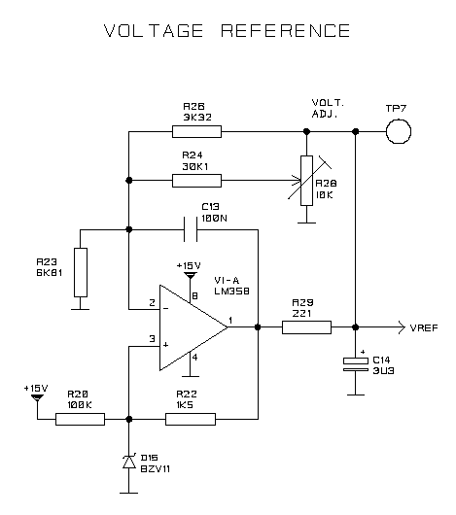
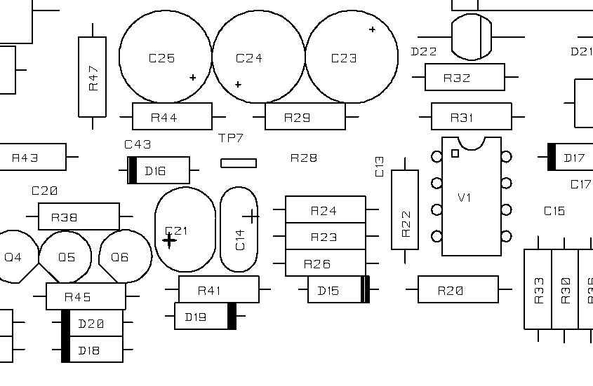

C14:
Note polarity

